October 11th, 2009
Hi,
Not too much to write about this week.
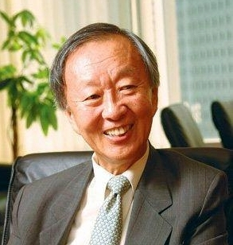
You probably heard that Charles Kao, who was Vice-Chancellor (equivalent to President in universities of the United States) of the Chinese University of Hong Kong from 1987 to 1996, was awarded the Nobel Prize in Physics for his work on fibre optics. Did you ever come across him when we were at CUHK? I only met and talked with hom once when he had arranged a lunch for us from the Faculty of Education. He was born in Shanghai, completed his secondary education at St Joseph’s College in HK and did his university study in the UK. His pioneering work in fibre optics actually goes back to the mid-1960s. The expansion of the Internet was only possible because of his work. This is the first time that a Nobel prize has been awarded for applied Physics. He lives in the UK but as his children work in Silicon Valley, also has a home in San Francisco where he is at the moment. He has citizenship in HK, the UK and the USA. He is now suffering from Alzheimer’s disease and when I saw him on TV last night being interviewed, he often could not remember words and had to be helped.
Also, you are probably aware that a guy from MGH and Harvard Medical School was one of the three people awarded the Nobel prize in Medicine. One of the two ladies who received this award is from Australia. And fancy Obama winning the Nobel Peace Prize. Surely it is a bit premature as he has not actually achieved much in the way of peace-making yet.
Did you hear that Rugby 7s, along with golf, was admitted into the Olympic Games from 2016 on? The IOC vote for Rugby 7s was almost unanimous which was not the case for golf. As a result of this, the four-yearly Rugby 7s world cup will probably be stopped in favour of the Olympics.
I was looking at the letter for this weekend last year. In it, I mentioned that my exercise consisted of five days of swimming doing 5 km on one day and 20 km for the week. The 5 km swim took about 2 hr 20 min. I think this may be my longest distance for a single swim. I certainly have not got anywhere near those distances this year and have not done more than three swims in one week.
That’s about it for now.
Cheers

